LAMPIRAN KODING PENUNJANG

finformasi.xml
<?xml version="1.0" encoding="utf-8"?>
<LinearLayout
xmlns:android="http://schemas.android.com/apk/res/android"
android:layout_width="match_parent"
android:layout_height="match_parent"
android:background = "#b8e4fb"
android:orientation="vertical">

<TableLayout
android:layout_width="wrap_content"
android:layout_height="wrap_content" android:orientation="vertical">
<TableRow>

<Button
android:id = "@+id/menu"
android:layout_marginTop = "5dp"
android:layout_width = "wrap_content"
android:layout_height= "wrap_content"
android:background = "@drawable/home"
/>

</TableRow>
</TableLayout>

<ScrollView
android:layout_width = "fill_parent"
android:layout_height= "wrap_content"
>

<LinearLayout
android:gravity = "center"
android:layout_width="match_parent"
android:layout_height="match_parent"
android:background = "@drawable/bgutama"
android:layout_marginTop = "10dp"
android:layout_marginLeft = "7dp"
android:layout_marginRight= "7dp"
android:layout_marginBottom= "10dp"
android:layout_gravity = "center"
android:orientation="vertical">

<Button
android:id = "@+id/tandakehamilan"
android:layout_width = "wrap_content"
android:layout_height = "wrap_content"
android:layout_gravity = "center"
android:layout_marginTop = "10dp"
android:background = "@drawable/tandakehamilan"
/>

<Button
android:id = "@+id/Nutrisi"
android:layout_width = "wrap_content"
android:layout_height= "wrap_content"
android:layout_gravity = "center"
android:background = "@drawable/nutrisipenting"
/>

<Button
android:id = "@+id/PrinsipMakanan"
android:layout_width = "wrap_content"
android:layout_height = "wrap_content"
android:layout_gravity = "center"
android:background = "@drawable/prinsipmakananygbaik"
/>

<Button
android:id = "@+id/MakananYangDihindari"
android:layout_width = "wrap_content"
android:layout_height = "wrap_content"
android:layout_gravity = "center"
android:background = "@drawable/makananygharusdihindari"
/>

<Button
android:id = "@+id/PosisiTidur"
android:layout_width = "wrap_content"
android:layout_height = "wrap_content"
android:layout_gravity = "center"
android:background = "@drawable/posisitidurygbaik"
/>

<Button
android:id = "@+id/KiatLakiPerempuan"
android:layout_width = "wrap_content"
android:layout_height = "wrap_content"
android:layout_gravity = "center"
android:background = "@drawable/kiatmendapatkanbayilp"
/>

</LinearLayout>
</ScrollView>
</LinearLayout>

fmakananyangdihindari.xml
<?xml version="1.0" encoding="utf-8"?>
<LinearLayout
xmlns:android="http://schemas.android.com/apk/res/android"
android:layout_width="match_parent"
android:layout_height="match_parent"
android:background = "#b8e4fb"
android:orientation="vertical">

<TableLayout
android:layout_width = "wrap_content"
android:layout_height= "wrap_content"
android:orientation = "vertical"
>
<TableRow>
<Button
android:id = "@+id/menu"
android:layout_marginTop = "5dp"
android:layout_width = "wrap_content"
android:layout_height= "wrap_content"
android:background = "@drawable/home"
/>

<Button
android:id = "@+id/informasi"
android:layout_marginTop = "5dp"
android:layout_width = "wrap_content"
android:layout_height= "wrap_content"
android:background = "@drawable/infokehamilan"
/>

</TableRow>
</TableLayout>

<LinearLayout
android:layout_marginTop = "5dp"
android:layout_marginLeft = "7dp"
android:layout_marginRight= "7dp"
android:layout_marginBottom= "10dp"
android:layout_width="fill_parent"
android:layout_height="fill_parent"
android:layout_gravity = "center"
android:background = "@drawable/bgutama"
android:orientation="vertical">

<TextView
android:layout_width = "wrap_content"
android:layout_height= "wrap_content"
android:layout_gravity = "center"
android:gravity = "center"
android:text = "Makanan Yang Harus Dihindari"
android:textColor = "#ffffff"
android:textSize = "20dp"
>
</TextView>

<TextView
android:id = "@+id/namamakananygdihindari"
android:layout_width = "wrap_content"
android:layout_height = "wrap_content"
android:layout_gravity = "center"
android:layout_marginBottom = "5dp"
android:text = "Daging Mentah"
android:textColor = "#ffffff"
android:textSize = "15dp"
android:textStyle = "bold"
/>

<ImageView android:id="@+id/IVMakananygdihindari"
android:src = "@drawable/dagingmentah"
android:layout_width="235dp"
android:layout_height="135dp"
android:layout_gravity = "center"
android:layout_marginBottom = "5dp"
>
</ImageView>

<ScrollView
android:layout_width = "fill_parent"
android:layout_height = "100dp">

<LinearLayout
android:layout_width = "fill_parent"
android:layout_height = "wrap_content"
android:orientation = "vertical">

<TextView
android:id = "@+id/infomakananygdihindari"
android:layout_width = "fill_parent"
android:layout_height= "wrap_content"
android:textSize = "13dp"
android:gravity = "left"
android:textColor = "#ffffff"
android:text = ""

/>

</LinearLayout>
</ScrollView>

<HorizontalScrollView
android:layout_width ="fill_parent"
android:layout_height = "wrap_content"
android:layout_gravity = "center">

<LinearLayout
android:layout_width = "fill_parent"
android:layout_height = "wrap_content"
android:orientation = "horizontal">

<ImageView android:id="@+id/IVMakananygdihindari1"
android:src = "@drawable/dagingmentah"
android:layout_width="75dp"
android:layout_height="75dp"
android:padding = "10dp">
</ImageView>

<ImageView android:id="@+id/IVMakananygdihindari2"
android:src = "@drawable/toksoplasmosis"
android:layout_width="75dp"
android:layout_height="75dp"
android:padding = "10dp">
</ImageView>

<ImageView android:id="@+id/IVMakananygdihindari3"
android:src = "@drawable/telursetengahmatang"
android:layout_width="75dp"
android:layout_height="75dp"
android:padding = "10dp">
</ImageView>

<ImageView android:id="@+id/IVMakananygdihindari4"
android:src = "@drawable/dagingikantuna"
android:layout_width="75dp"
android:layout_height="75dp"
android:padding = "10dp">
</ImageView>

<ImageView android:id="@+id/IVMakananygdihindari5"
android:src = "@drawable/kejulunakbrie"
android:layout_width="75dp"
android:layout_height="75dp"
android:padding = "10dp">
</ImageView>

<ImageView android:id="@+id/IVMakananygdihindari6"
android:src = "@drawable/alcohol"
android:layout_width="75dp"
android:layout_height="75dp"
android:padding = "10dp">
</ImageView>

<ImageView android:id="@+id/IVMakananygdihindari7"
android:src = "@drawable/kopi"
android:layout_width="75dp"
android:layout_height="75dp"
android:padding = "10dp">
</ImageView>

</LinearLayout>
</HorizontalScrollView>

</LinearLayout>
</LinearLayout>

fnamalaki.xml
<?xml version="1.0" encoding="utf-8"?>
<LinearLayout xmlns:android="http://schemas.android.com/apk/res/android"
android:orientation="vertical"
android:background = "#b8e4fb"
android:layout_width="fill_parent"
android:layout_height="fill_parent"
>

<Button
android:id = "@+id/menu"
android:layout_marginTop = "5dp"
android:layout_width = "wrap_content"
android:layout_height= "wrap_content"
android:background = "@drawable/home"
/>

<LinearLayout
android:orientation="vertical"
android:layout_width="fill_parent"
android:layout_height="fill_parent"
android:background = "@drawable/bgutama"
android:layout_marginTop = "10dp"
android:layout_marginLeft = "7dp"
android:layout_marginRight= "7dp"
android:layout_marginBottom= "10dp"
>

<TableLayout
android:layout_width = "fill_parent"
android:layout_height= "wrap_content"
>

<TableRow>

<TextView
android:layout_width = "wrap_content"
android:layout_height= "wrap_content"
android:text = "Tulias Satu Alphabet : "
android:textColor = "#ffffff"
/>

<EditText
android:id = "@+id/pilNamaLaki"
android:layout_marginBottom = "10dp"
android:layout_width = "fill_parent"
android:layout_height= "wrap_content"
android:text = "a"
/>

</TableRow>
</TableLayout>

<Button
android:id = "@+id/okNamaLaki"
android:layout_marginBottom = "10dp"
android:layout_width = "fill_parent"
android:layout_height= "wrap_content"
android:text = "ok"
/>

<HorizontalScrollView
android:layout_width = "fill_parent"
android:layout_height= "wrap_content">

<ScrollView
android:layout_width = "fill_parent"
android:layout_height= "wrap_content">

<!-- THE DATA TABLE -->
<TableLayout
android:id="@+id/lytLinearNamalaki"
android:layout_width="fill_parent"
android:layout_height="wrap_content"
>
<TableRow>
<TextView
android:layout_marginRight = "5dp"
android:text="Nama"
android:minWidth="80px"
android:textSize="17sp"
android:textColor = "#000000"
android:gravity = "center"
android:background = "#b8e4fb"
/>
<TextView
android:text="Arti"
android:minWidth="180dp"
android:textSize="17sp"
android:textColor = "#000000"
android:gravity = "center"
android:background = "#b8e4fb"
/>

</TableRow>
</TableLayout>

</ScrollView>
</HorizontalScrollView>

</LinearLayout>
</LinearLayout>

fperkembangan.xml
<?xml version="1.0" encoding="utf-8"?>
<LinearLayout xmlns:android="http://schemas.android.com/apk/res/android"
android:layout_width="match_parent"
android:layout_height="match_parent"
android:baselineAligned="false"
android:background = "#b8e4fb"
android:orientation="vertical">

<Button
android:id = "@+id/menu"
android:layout_marginTop = "5dp"
android:layout_width = "wrap_content"
android:layout_height= "wrap_content"
android:background = "@drawable/home"
/>

<LinearLayout
android:layout_marginTop = "5dp"
android:layout_marginLeft = "5dp"
android:layout_marginRight= "5dp"
android:layout_marginBottom= "5dp"
android:layout_width="fill_parent"
android:layout_height="fill_parent"
android:background = "@drawable/bgutama"
android:layout_gravity = "center"
android:orientation="vertical">

<TextView
android:layout_width = "wrap_content"
android:layout_height= "wrap_content"
android:layout_gravity = "center"
android:layout_marginBottom = "7dp"
android:textColor = "#ffffff"
android:text = "Perkembangan Janin"
android:textSize = "20dp"
>
</TextView>

<TextView
android:id = "@+id/infobulan"
android:layout_width = "wrap_content"
android:layout_height = "wrap_content"
android:layout_gravity = "center"
android:textColor = "#ffffff"
android:text = "BULAN PERTAMA"
android:layout_marginBottom = "7dp"
android:textSize = "15dp"
android:textStyle = "bold"
/>

<ImageView android:id="@+id/IVDisplay"
android:src = "@drawable/b1"
android:layout_width="235dp"
android:layout_height="135dp"
android:layout_marginBottom = "5dp"
android:layout_gravity = "center"
>
</ImageView>

<ScrollView
android:layout_width = "fill_parent"
android:layout_height = "105dp">

<LinearLayout
android:layout_width = "fill_parent"
android:layout_height = "wrap_content"
android:orientation = "vertical">

<TextView
android:id = "@+id/info"
android:layout_width = "fill_parent"
android:layout_height= "wrap_content"
android:textSize = "13dp"
android:gravity = "left"
android:layout_marginBottom = "15dp"
android:textColor = "#ffffff"

/>

</LinearLayout>
</ScrollView>

<HorizontalScrollView
android:layout_width ="300dp"
android:layout_height = "wrap_content"
android:layout_gravity = "center">

<LinearLayout
android:layout_width = "fill_parent"
android:layout_height = "wrap_content"
android:orientation = "horizontal">

<ImageView android:id="@+id/IVimage1"
android:src = "@drawable/b1"
android:layout_width="75dp"
android:layout_height="75dp"
android:padding = "10dp">
</ImageView>

<ImageView android:id="@+id/IVimage2"
android:src = "@drawable/b2"
android:layout_width="75dp"
android:layout_height="75dp"
android:padding = "10dp">
</ImageView>

<ImageView android:id="@+id/IVimage3"
android:src = "@drawable/b3"
android:layout_width="75dp"
android:layout_height="75dp"
android:padding = "10dp">
</ImageView>

<ImageView android:id="@+id/IVimage4"
android:src = "@drawable/b4"
android:layout_width="75dp"
android:layout_height="75dp"
android:padding = "10dp">
</ImageView>

<ImageView android:id="@+id/IVimage5"
android:src = "@drawable/b5"
android:layout_width="75dp"
android:layout_height="75dp"
android:padding = "10dp">
</ImageView>

<ImageView android:id="@+id/IVimage6"
android:src = "@drawable/b6"
android:layout_width="75dp"
android:layout_height="75dp"
android:padding = "10dp">
</ImageView>

<ImageView android:id="@+id/IVimage7"
android:src = "@drawable/b7"
android:layout_width="75dp"
android:layout_height="75dp"
android:padding = "10dp">
</ImageView>

<ImageView android:id="@+id/IVimage8"
android:src = "@drawable/b8"
android:layout_width="75dp"
android:layout_height="75dp"
android:padding = "10dp">
</ImageView>

<ImageView android:id="@+id/IVimage9"
android:src = "@drawable/b9"
android:layout_width="75dp"
android:layout_height="75dp"
android:padding = "10dp">
</ImageView>

</LinearLayout>
</HorizontalScrollView>
</LinearLayout>
</LinearLayout>

fprinsipmakanan.xml
<?xml version="1.0" encoding="utf-8"?>
<LinearLayout
xmlns:android="http://schemas.android.com/apk/res/android"
android:layout_width="match_parent"
android:layout_height="match_parent"
android:background = "#b8e4fb"
android:orientation="vertical">

<TableLayout
android:layout_width = "wrap_content"
android:layout_height= "wrap_content"
android:orientation = "vertical"
>
<TableRow>
<Button
android:id = "@+id/menu"
android:layout_marginTop = "5dp"
android:layout_width = "wrap_content"
android:layout_height= "wrap_content"
android:background = "@drawable/home"
/>

<Button
android:id = "@+id/informasi"
android:layout_marginTop = "5dp"
android:layout_width = "wrap_content"
android:layout_height= "wrap_content"
android:background = "@drawable/infokehamilan"
/>

</TableRow>
</TableLayout>

<LinearLayout
android:layout_marginTop = "5dp"
android:layout_marginLeft = "7dp"
android:layout_marginRight= "7dp"
android:layout_marginBottom= "10dp"
android:layout_width="fill_parent"
android:layout_height="fill_parent"
android:background = "@drawable/bgutama"
android:orientation="vertical">

<TextView
android:id = "@+id/p1pm"
android:gravity = "center"
android:layout_width = "fill_parent"
android:layout_height= "wrap_content"
android:textStyle = "bold"
android:textSize = "16dp"
android:textColor = "#ffffff"
android:text = ""
/>

<ScrollView
android:layout_width = "fill_parent"
android:layout_height= "wrap_content"
>

<LinearLayout
android:layout_width = "fill_parent"
android:layout_height= "wrap_content"
android:orientation = "vertical"
>

<TextView
android:layout_width="fill_parent"
android:layout_height="5dp"
/>

<TextView
android:id = "@+id/p2pm"
android:layout_width = "fill_parent"
android:layout_height= "wrap_content"
android:textColor = "#ffffff"
android:text = ""
/>

<TextView
android:layout_width="fill_parent"
android:layout_height="5dp"
/>

<TextView
android:id = "@+id/p3pm"
android:layout_width = "fill_parent"
android:layout_height= "wrap_content"
android:textColor = "#ffffff"
android:text = ""
/>

<TextView
android:layout_width="fill_parent"
android:layout_height="5dp"
/>

<TextView
android:id = "@+id/p4pm"
android:layout_width = "fill_parent"
android:layout_height= "wrap_content"
android:textColor = "#ffffff"
android:text = ""
/>

<TextView
android:layout_width="fill_parent"
android:layout_height="5dp"
/>

<TextView
android:id = "@+id/p5pm"
android:layout_width = "fill_parent"
android:layout_height= "wrap_content"
android:textColor = "#ffffff"
android:text = ""
/>

<TextView
android:layout_width="fill_parent"
android:layout_height="5dp"
/>

<TextView
android:id = "@+id/p6pm"
android:layout_width = "fill_parent"
android:layout_height= "wrap_content"
android:textColor = "#ffffff"
android:text = ""
/>

<TextView
android:layout_width="fill_parent"
android:layout_height="15dp"
/>

<TextView
android:id = "@+id/p7pm"
android:layout_width = "fill_parent"
android:layout_height= "wrap_content"
android:textColor = "#ffffff"
android:text = ""
/>

<TextView
android:layout_width="fill_parent"
android:layout_height="5dp"
/>

<TextView
android:id = "@+id/p8pm"
android:layout_width = "fill_parent"
android:layout_height= "wrap_content"
android:textColor = "#ffffff"
android:text = ""
/>

<TextView
android:layout_width="fill_parent"
android:layout_height="5dp"
/>

<TextView
android:id = "@+id/p9pm"
android:layout_width = "fill_parent"
android:layout_height= "wrap_content"
android:textColor = "#ffffff"
android:text = ""
/>

<TextView
android:layout_width="fill_parent"
android:layout_height="5dp"
/>

<TextView
android:id = "@+id/p10pm"
android:layout_width = "fill_parent"
android:layout_height= "wrap_content"
android:textColor = "#ffffff"
android:text = ""
/>

<TextView
android:layout_width="fill_parent"
android:layout_height="5dp"
/>

<TextView
android:id = "@+id/p11pm"
android:layout_width = "fill_parent"
android:layout_height= "wrap_content"
android:textColor = "#ffffff"
android:text = ""
/>

<TextView
android:layout_width="fill_parent"
android:layout_height="5dp"
/>

<TextView
android:id = "@+id/p12pm"
android:layout_width = "fill_parent"
android:layout_height= "wrap_content"
android:textColor = "#ffffff"
android:text = ""
/>

<TextView
android:layout_width="fill_parent"
android:layout_height="5dp"
/>

<TextView
android:id = "@+id/p13pm"
android:layout_width = "fill_parent"
android:layout_height= "wrap_content"
android:textColor = "#ffffff"
android:text = ""
/>

<TextView
android:layout_width="fill_parent"
android:layout_height="5dp"
/>

<TextView
android:id = "@+id/p14pm"
android:layout_width = "fill_parent"
android:layout_height= "wrap_content"
android:textColor = "#ffffff"
android:text = ""
/>

<TextView
android:layout_width="fill_parent"
android:layout_height="5dp"
/>

<TextView
android:id = "@+id/p15pm"
android:layout_width = "fill_parent"
android:layout_height= "wrap_content"
android:textColor = "#ffffff"
android:text = ""
/>

<TextView
android:layout_width="fill_parent"
android:layout_height="5dp"
/>

<TextView
android:id = "@+id/p16pm"
android:layout_width = "fill_parent"
android:layout_height= "wrap_content"
android:textColor = "#ffffff"
android:text = ""
/>

<TextView
android:layout_width="fill_parent"
android:layout_height="5dp"
/>

<TextView
android:id = "@+id/p17pm"
android:layout_width = "fill_parent"
android:layout_height= "wrap_content"
android:textColor = "#ffffff"
android:text = ""
/>

<TextView
android:layout_width="fill_parent"
android:layout_height="5dp"
/>

<TextView
android:id = "@+id/p18pm"
android:layout_width = "fill_parent"
android:layout_height= "wrap_content"
android:textColor = "#ffffff"
android:text = ""
/>

<TextView
android:layout_width="fill_parent"
android:layout_height="5dp"
/>

<TextView
android:id = "@+id/p19pm"
android:layout_width = "fill_parent"
android:layout_height= "wrap_content"
android:textColor = "#ffffff"
android:text = ""
/>

</LinearLayout>
</ScrollView>
</LinearLayout>
</LinearLayout>

fnutrisi.xml
<?xml version="1.0" encoding="utf-8"?>
<LinearLayout xmlns:android="http://schemas.android.com/apk/res/android"
android:layout_width="match_parent"
android:layout_height="match_parent"
android:background = "#b8e4fb"
android:orientation="vertical">

<TableLayout
android:layout_width = "wrap_content"
android:layout_height= "wrap_content"
android:orientation = "vertical"
>
<TableRow>
<Button
android:id = "@+id/menu"
android:layout_marginTop = "5dp"
android:layout_width = "wrap_content"
android:layout_height= "wrap_content"
android:background = "@drawable/home"
/>

<Button
android:id = "@+id/informasi"
android:layout_marginTop = "5dp"
android:layout_width = "wrap_content"
android:layout_height= "wrap_content"
android:background = "@drawable/infokehamilan"
/>

</TableRow>
</TableLayout>

<LinearLayout
android:layout_marginTop = "5dp"
android:layout_marginLeft = "7dp"
android:layout_marginRight= "7dp"
android:layout_marginBottom= "10dp"
android:layout_width="fill_parent"
android:layout_height="fill_parent"
android:layout_gravity = "center"
android:background = "@drawable/bgutama"
android:orientation="vertical">

<TextView
android:layout_width = "wrap_content"
android:layout_height= "wrap_content"
android:layout_gravity = "center"
android:gravity = "center"
android:text = "Nutrisi Penting Selama Kehamilan"
android:textColor = "#ffffff"
android:textSize = "20dp"
>
</TextView>

<TextView
android:id = "@+id/namanutrisi"
android:layout_width = "wrap_content"
android:layout_height = "wrap_content"
android:layout_gravity = "center"
android:text = "Karbohidrat"
android:textColor = "#ffffff"
android:textSize = "15dp"
android:textStyle = "bold"
/>

<ImageView android:id="@+id/IVNutrisi"
android:src = "@drawable/karbohidrat"
android:layout_width="2350dp"
android:layout_height="135dp"
android:layout_gravity = "center"
android:layout_marginBottom = "5dp"
>
</ImageView>

<ScrollView
android:layout_width = "fill_parent"
android:layout_height = "80dp">

<LinearLayout
android:layout_width = "fill_parent"
android:layout_height = "wrap_content"
android:orientation = "vertical">

<TextView
android:id = "@+id/infonutrisi"
android:layout_width = "fill_parent"
android:layout_height= "wrap_content"
android:textSize = "13dp"
android:gravity = "left"
android:textColor = "#ffffff"
android:text = ""

/>

</LinearLayout>
</ScrollView>

<HorizontalScrollView
android:layout_width ="fill_parent"
android:layout_height = "wrap_content"
android:layout_gravity = "center">

<LinearLayout
android:layout_width = "fill_parent"
android:layout_height = "wrap_content"
android:orientation = "horizontal">

<ImageView android:id="@+id/IVnutrisi1"
android:src = "@drawable/karbohidrat"
android:layout_width="75dp"
android:layout_height="75dp"
android:padding = "10dp">
</ImageView>

<ImageView android:id="@+id/IVnutrisi2"
android:src = "@drawable/protein"
android:layout_width="75dp"
android:layout_height="75dp"
android:padding = "10dp">
</ImageView>

<ImageView android:id="@+id/IVnutrisi3"
android:src = "@drawable/mineral"
android:layout_width="75dp"
android:layout_height="75dp"
android:padding = "10dp">
</ImageView>

<ImageView android:id="@+id/IVnutrisi4"
android:src = "@drawable/vitaminb"
android:layout_width="75dp"
android:layout_height="75dp"
android:padding = "10dp">
</ImageView>

<ImageView android:id="@+id/IVnutrisi5"
android:src = "@drawable/vitamind"
android:layout_width="75dp"
android:layout_height="75dp"
android:padding = "10dp">
</ImageView>

<ImageView android:id="@+id/IVnutrisi6"
android:src = "@drawable/vitamine"
android:layout_width="75dp"
android:layout_height="75dp"
android:padding = "10dp">
</ImageView>

<ImageView android:id="@+id/IVnutrisi7"
android:src = "@drawable/asamfolat"
android:layout_width="75dp"
android:layout_height="75dp"
android:padding = "10dp">
</ImageView>

<ImageView android:id="@+id/IVnutrisi8"
android:src = "@drawable/zatbesi"
android:layout_width="75dp"
android:layout_height="75dp"
android:padding = "10dp">
</ImageView>

<ImageView android:id="@+id/IVnutrisi9"
android:src = "@drawable/kalsium"
android:layout_width="75dp"
android:layout_height="75dp"
android:padding = "10dp">
</ImageView>

</LinearLayout>
</HorizontalScrollView>

</LinearLayout>
</LinearLayout>

informasi.java
package com.firdan;

import android.app.Activity;
import android.content.Intent;
import android.os.Bundle;
import android.view.View;
import android.widget.Button;

public class informasi extends Activity{

Button bMenu,bTandaKehamilan, bNutrisi, bPosisiTidur, bPrinsipMakanan, bKiatbayi, bMakananYangDihindari;

@Override
protected void onCreate(Bundle savedInstanceState) {
// TODO Auto-generated method stub
super.onCreate(savedInstanceState);
setContentView (R.layout.finformasi);

bMenu = (Button) findViewById (R.id.menu);
bMenu.setOnClickListener(new View.OnClickListener() {

public void onClick(View arg0) {
// TODO Auto-generated method stub
startActivity (new Intent ("com.firdan.MENU"));
}
});

bTandaKehamilan = (Button) findViewById (R.id.tandakehamilan);
bTandaKehamilan.setOnClickListener(new View.OnClickListener() {

public void onClick(View arg0) {
// TODO Auto-generated method stub
startActivity (new Intent ("com.firdan.FORMTANDAKEHAMILAN"));

}
});

bNutrisi = (Button) findViewById (R.id.Nutrisi);
bNutrisi.setOnClickListener(new View.OnClickListener() {

public void onClick(View arg0) {
// TODO Auto-generated method stub
startActivity (new Intent("com.firdan.FORMNUTRISI"));
}
});

bPosisiTidur = (Button) findViewById (R.id.PosisiTidur);
bPosisiTidur.setOnClickListener(new View.OnClickListener() {

public void onClick(View arg0) {
// TODO Auto-generated method stub
startActivity (new Intent("com.firdan.FORMPOSISITIDUR"));
}
});

bPrinsipMakanan = (Button) findViewById (R.id.PrinsipMakanan);
bPrinsipMakanan.setOnClickListener(new View.OnClickListener() {

public void onClick(View arg0) {
// TODO Auto-generated method stub
startActivity (new Intent("com.firdan.FORMPRINSIPMAKANAN"));
}
});

bKiatbayi = (Button) findViewById (R.id.KiatLakiPerempuan);
bKiatbayi.setOnClickListener(new View.OnClickListener() {

public void onClick(View arg0) {
// TODO Auto-generated method stub
startActivity (new Intent("com.firdan.FORMKIATBAYI"));
}
});

bMakananYangDihindari = (Button) findViewById (R.id.MakananYangDihindari);
bMakananYangDihindari.setOnClickListener(new View.OnClickListener() {

public void onClick(View arg0) {
// TODO Auto-generated method stub
startActivity (new Intent("com.firdan.FORMMAKANANYANGDIHINDARI"));

}
});

}

}

Makananyangdihindari.java
package com.firdan;

import android.app.Activity;
import android.content.Intent;
import android.os.Bundle;
import android.widget.Button;
import android.widget.ImageView;
import android.widget.TextView;
import android.view.*;
import android.view.View.OnClickListener;

public class Makananyangdihindari extends Activity implements OnClickListener {
Button bmenu, binfo;
ImageView display;
TextView informasimakananygdihindari, namamakananygdihindari;

@Override
protected void onCreate(Bundle savedInstanceState) {
// TODO Auto-generated method stub
super.onCreate(savedInstanceState);
setContentView (R.layout.fmakananyangdihindari);

bmenu = (Button) findViewById (R.id.menu);
bmenu.setOnClickListener(new View.OnClickListener() {

public void onClick(View v) {
// TODO Auto-generated method stub
startActivity (new Intent ("com.firdan.MENU"));
}
});

binfo = (Button) findViewById (R.id.informasi);
binfo.setOnClickListener(new View.OnClickListener() {

public void onClick(View v) {
// TODO Auto-generated method stub
startActivity (new Intent("com.firdan.FORMINFORMASI"));
}
});

display = (ImageView) findViewById (R.id.IVMakananygdihindari);
ImageView gambar1 = (ImageView) findViewById(R.id.IVMakananygdihindari1);
ImageView gambar2 = (ImageView) findViewById(R.id.IVMakananygdihindari2);
ImageView gambar3 = (ImageView) findViewById(R.id.IVMakananygdihindari3);
ImageView gambar4 = (ImageView) findViewById(R.id.IVMakananygdihindari4);
ImageView gambar5 = (ImageView) findViewById(R.id.IVMakananygdihindari5);
ImageView gambar6 = (ImageView) findViewById(R.id.IVMakananygdihindari6);
ImageView gambar7 = (ImageView) findViewById(R.id.IVMakananygdihindari7);

namamakananygdihindari = (TextView) findViewById (R.id.namamakananygdihindari);
informasimakananygdihindari = (TextView) findViewById (R.id.infomakananygdihindari);

gambar1.setOnClickListener(this);
gambar2.setOnClickListener(this);
gambar3.setOnClickListener(this);
gambar4.setOnClickListener(this);
gambar5.setOnClickListener(this);
gambar6.setOnClickListener(this);
gambar7.setOnClickListener(this);

}

public void onClick(View v) {
// TODO Auto-generated method stub

String p1 = "1. Jangan makan daging mentah seperti sushi misalnya atau yang dimasak kurang matang, karena makanan itu mengandung toksoplasmosis, yakni sebuah parasit yang dapat menyebabkan infeksi serius pada janin anda dan juga ecoli, yang berbahaya bagi ibu hamil dan janin.";
String p2 = "2. Toksoplasmosis terdapat pada sayuran yang tidak dicuci dengan baik. Oleh karena itu, bersihkan sayuran anda dengan baik, apalagi untuk salad dan lalapan yang dimakan dengan mentah. Hindari juga kotoran kucing atau bermain-main dengan kucing selama kehamilan, karena itu juga mengandung toksoplasmosis.";
String p3 = "3. Jangan makan daging ayam atau telur yang dimasak kurang matang atau mentah. Hindari juga makan hati ayam/daging yang mungkin sumber dari salmonella, yang dapat menyebabkan diare yang berat pada ibu hamil. Juga diperhatikan piring dan alat-alat masakan yang terkena daging ayam mentah ini, cucilah dengan bersih alat-alat makan tersebut.";
String p4 = "4. Ikan tuna steak, ikan sea bass, hiu, atau ikan-ikan berukuran besar yang diketahui mengandung tingkat merkuri yang tinggi juga dapat mengakibatkan kerusakan saraf jika dimakan dalam jumlah yang besar. FDA merekomendasikan memakan ikan tuna dan ikan ukuran besar lainnya sebanyak 12 ons perminggu.";
String p5 = "5. Jangan makan keju lunak seperti brie dan camembert, blueveined cheese, juga keju dari susu kambing dan domba, serta jangan minum susu yang tidak dipasteurisasi. Semua produk ini beresiko membawa listria. Listria adalah tipe bakteri yang mampu menembus plasenta dan menyebabkan infeksi janin, sedangkan pada dewaswa tidak ada gejala seperti flu. Listria dapat menyebabkan keguguran, kelahiran prematur dan keracunan dalam darah. Sebaiknya hindari makanan jenis ini sampai anda melahirkan bayi anda.";
String p6 = "6. Jangan minum minuman yang mengandung alkohol, karena itu dapat menyebabkan kelainan perkembangan pada janin serta juga menimbulkan problem emosional pada bayi.";
String p7 = "7. Minuman yang mengandung kafein seperti kopi dan the sebaiknya dihindari atau dibatasi, karena kopi dapat mempengaruhi berat badan pada bayi dan juga keguguran serta kafein dapat mengurangi penyerapan zat besi.";

String j1 = "Daging Mentah";
String j2 = "Sayuran Yang Tidak Dicuci Bersih";
String j3 = "Makanan Setengah Matang";
String j4 = "Ikan Yang Mengandung Merkuri";
String j5 = "Keju Lunak";
String j6 = "Minuman Beralcohol";
String j7 = "Minuman Berkafein";

switch (v.getId()){

case R.id.IVMakananygdihindari1:
display.setImageResource(R.drawable.dagingmentah);
namamakananygdihindari.setText(String.valueOf(j1));
informasimakananygdihindari.setText(String.valueOf(p1));
break;
case R.id.IVMakananygdihindari2:
display.setImageResource(R.drawable.toksoplasmosis);
namamakananygdihindari.setText(String.valueOf(j2));
informasimakananygdihindari.setText(String.valueOf(p2));
break;
case R.id.IVMakananygdihindari3:
display.setImageResource(R.drawable.telursetengahmatang);
namamakananygdihindari.setText(String.valueOf(j3));
informasimakananygdihindari.setText(String.valueOf(p3));
break;
case R.id.IVMakananygdihindari4:
display.setImageResource(R.drawable.dagingikantuna);
namamakananygdihindari.setText(String.valueOf(j4));
informasimakananygdihindari.setText(String.valueOf(p4));
break;
case R.id.IVMakananygdihindari5:
display.setImageResource(R.drawable.kejulunakbrie);
namamakananygdihindari.setText(String.valueOf(j5));
informasimakananygdihindari.setText(String.valueOf(p5));
break;
case R.id.IVMakananygdihindari6:
display.setImageResource(R.drawable.alcohol);
namamakananygdihindari.setText(String.valueOf(j6));
informasimakananygdihindari.setText(String.valueOf(p6));
break;
case R.id.IVMakananygdihindari7:
display.setImageResource(R.drawable.kopi);
namamakananygdihindari.setText(String.valueOf(j7));
informasimakananygdihindari.setText(String.valueOf(p7));
break;
}
}
}

BacaDatabaseNamaLaki.java
package com.firdan;

import java.io.IOException;
import java.util.ArrayList;

import android.app.Activity;
import android.content.Intent;
import android.database.SQLException;
import android.graphics.Color;
import android.os.Bundle;
import android.view.View;
import android.widget.Button;
import android.widget.EditText;
import android.widget.TableLayout;
import android.widget.TableRow;
import android.widget.TextView;
import android.widget.Toast;

public class BacaDatabaseNamaLaki extends Activity {

TableLayout lytLinear;
Button OK, bmenu;
TextView txtNama, txtArti;
DBHelperNamaLaki myDbHelper;
EditText pilihan;
String pilNama;

/** Called when the activity is first created. */
@Override
public void onCreate(Bundle savedInstanceState) {
super.onCreate(savedInstanceState);
setContentView(R.layout.fnamalaki);

bmenu = (Button) findViewById (R.id.menu);
bmenu.setOnClickListener(new View.OnClickListener() {

public void onClick(View v) {
// TODO Auto-generated method stub
startActivity (new Intent ("com.firdan.MENU"));
}
});

pilihan = (EditText) findViewById (R.id.pilNamaLaki);

OK = (Button) findViewById (R.id.okNamaLaki);
OK.setOnClickListener(new View.OnClickListener() {

public void onClick(View v) {
// TODO Auto-generated method stub
pilNama = pilihan.getText().toString();
updateTable();
}
});

lytLinear = (TableLayout)findViewById(R.id.lytLinearNamalaki);
myDbHelper = new DBHelperNamaLaki(this);

try{
myDbHelper.createDataBase();
}catch (IOException ioe){
throw new Error ("Unable to creata database");
}
try{
Toast.makeText(this, "database dibuka", Toast.LENGTH_SHORT);
myDbHelper.openDataBase();
}catch (SQLException sqle){
throw sqle;
}
}

public void updateTable(){

Toast.makeText(this, "update table di akses", Toast.LENGTH_SHORT);
myDbHelper.openDataBase();

while (lytLinear.getChildCount() > 1){
lytLinear.removeViewAt(1);
}

ArrayList<ArrayList<Object>> data = myDbHelper.getAllRowsAsArrays(pilNama);

//buat baris baru setiap perulangan dan masukkan data ke dalam
//masing-masing baris

for (int position=0; position < data.size(); position++)
{

TableRow tableRow = new TableRow(this);

ArrayList<Object> row = data.get(position);

txtNama = new TextView(this);
txtNama.setText(row.get(0).toString());
txtNama.setTextColor(Color.BLACK);
tableRow.addView(txtNama);

if (position % 2 == 0){
txtNama.setBackgroundColor(Color.rgb(234, 234, 234));
}else{
txtNama.setBackgroundColor(Color.rgb(255, 255, 255));
}

txtArti = new TextView(this);
txtArti.setText(row.get(1).toString());
txtArti.setTextColor(Color.BLACK);
tableRow.addView(txtArti);

if (position % 2 == 0){
txtArti.setBackgroundColor(Color.rgb(234, 234, 234));
}else{
txtArti.setBackgroundColor(Color.rgb(255, 255, 255));
}

lytLinear.addView(tableRow);
}
}
}

Lampiran Output
- Halaman Utama Aplikasi Kehamilan
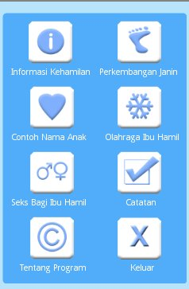

- Halaman Informasi Kehamilan
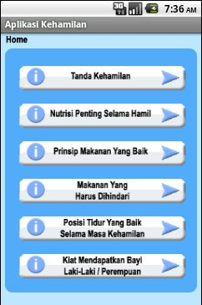

- Halaman Tanda Kehamilan
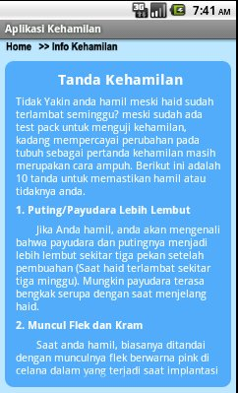

- Halaman Nutrisi Penting Selama Kehamilan
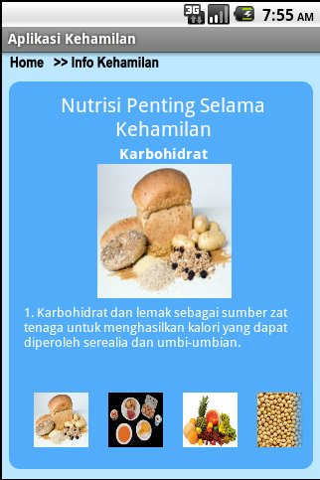

- Halaman Prinsip Makanan Yang Baik
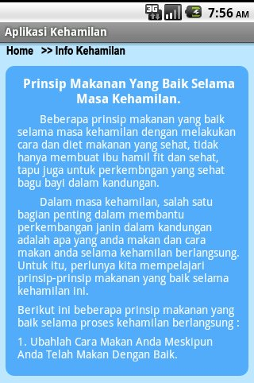

- Halaman Menu Makanan Yang Harus Dihindari
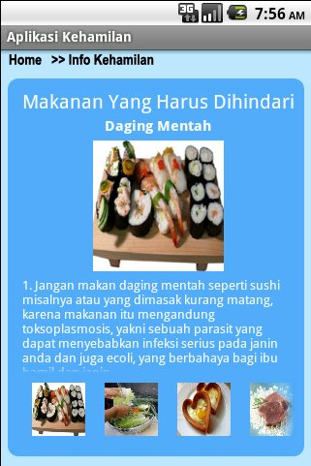

- Halaman Posisi Tidur Yang Baik Selama Kehamilan
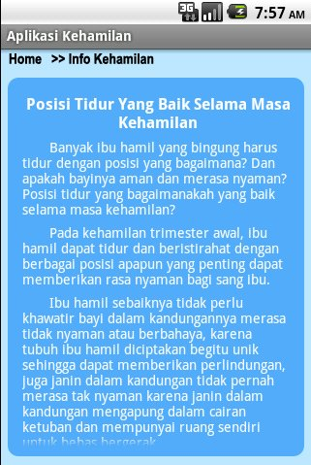

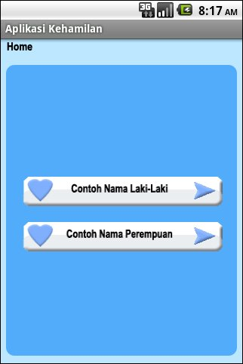
- Halaman Contoh Nama Anak

- Halaman Contoh Nama Anak Laki-Laki
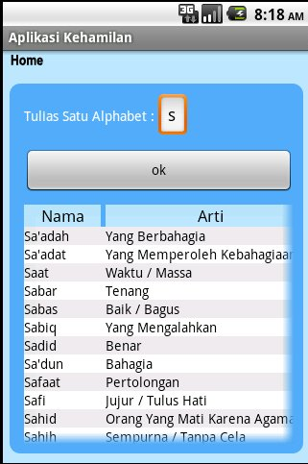

- Halaman Menu Olahraga
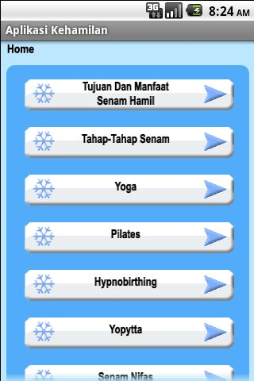

- Halaman Tujuan dan Manfaat Senam
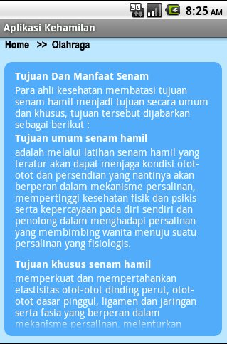

- Halaman Yoga
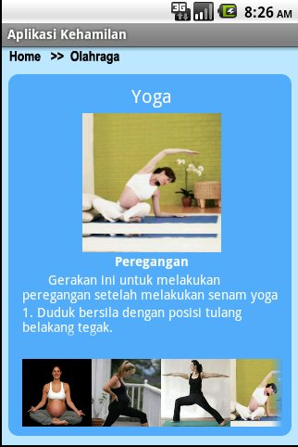

- Halaman Pilates
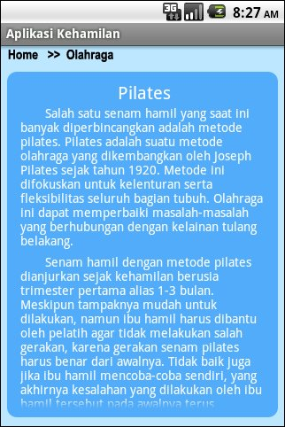

- Halaman Senam Nifas
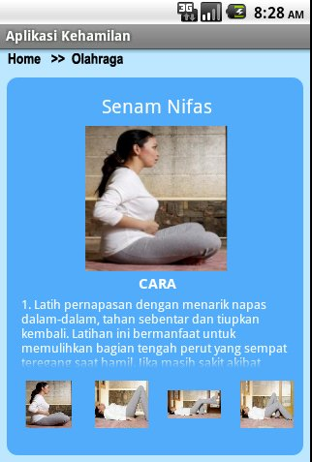

- Halaman Catatan
